1. Produce the list of order with the following details: item code, description and unit price given by Order-No & Vender-No.

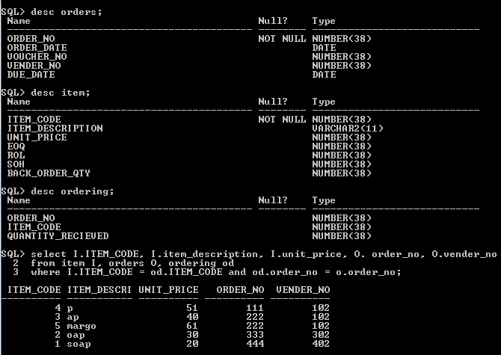

1. Produce the daily items receipt summary with the following details: Order-no, Order date, Vender no, vender date, vender address item code item description EOQ, quantity received.

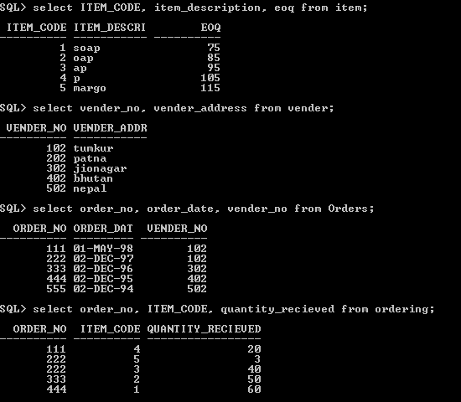

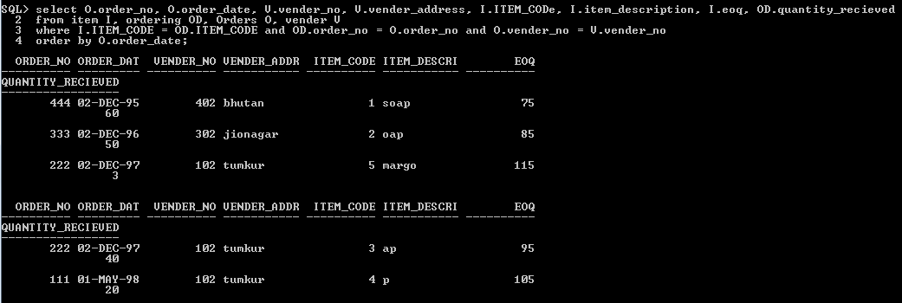

1. Produce the daily items issue summary with the following details: Indent no, section code, section name, item code, item description, quantity demanded, quantity issued.

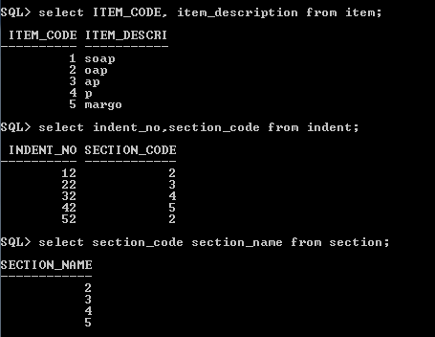

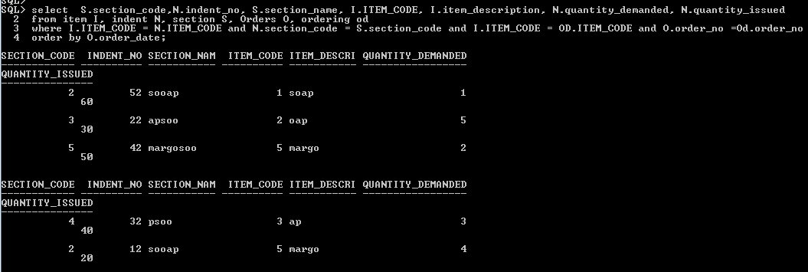

1. Produce the list of orders with the following details: order no, order date, due date, vender no and vender name, given by delay duration. [Note: Delay duration=current date- due date]

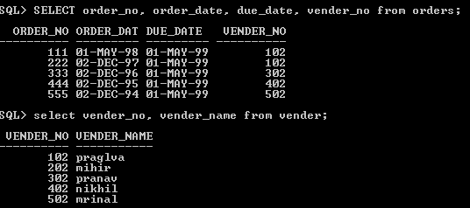

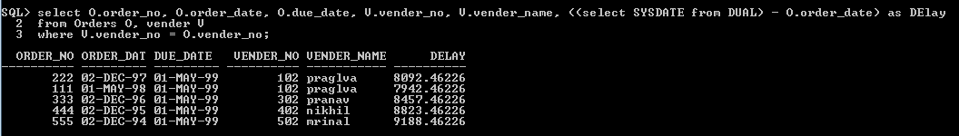

1. Produce the everyday bill payment voucher with the following details: item code, item description unit price, EOQ, quantity Received and item order value in Rs (EOQ \* quantity-received) given by order no, voucher no & vender no.

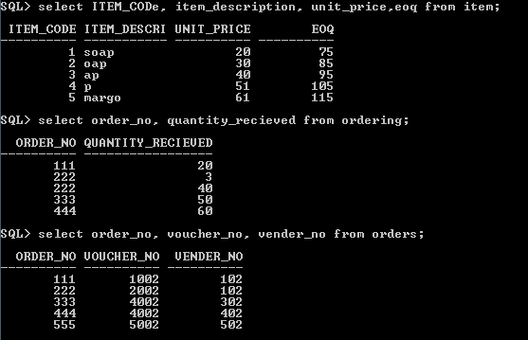



1. Produce the monthly bill settlement summery of given vendor no with the following details: voucher no, voucher date, cheque no, cheque date cheque amount

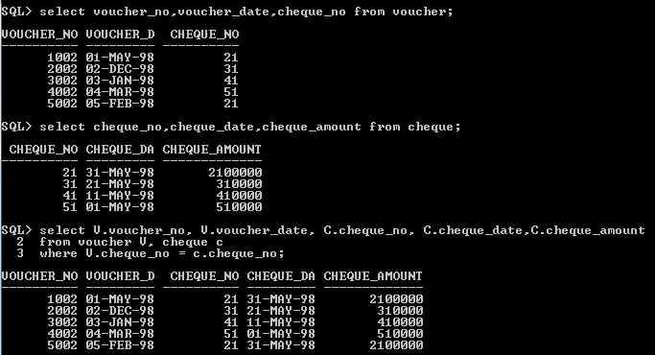

1. Produce the monthly stores materials consumption summary with the following details: item code, item description, Unit price, quantity consumed and item consumption values in Rs.

